MORE APPLICATIONS

- Area Moment of Inertia of a rectangular strip with moment axis at the cross sectional neutral axis. The value of the Moment of Inertia will be taken through the image generated by the first moment of unit areas:

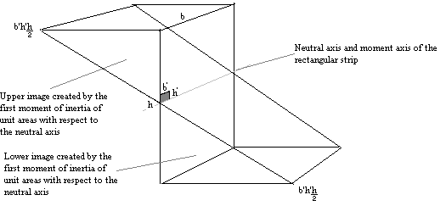

b’ x (no. of division of b) = b
h’ x (no. of division of h/2) = h/2

$$\sum{b'h'\frac{h}{2}=b\frac{h}{2}\frac{h}{2}\frac{1}{2}}=\frac{{\text{bh}}^{2}}{8}$$

½ of a rectangular prism created by
the dimensions b x h/2

Let I_{L} be the area moment of inertia of the lower image and I_{U}, the area moment of inertia of the upper image. By symmetry with respect to the moment axis, I_{L} is equal to I_{U}, thus I or total moment of inertia of the rectangular strip with to respect to the moment axis is 2I_{L} or 2I_{U}. To continue:

$$I_{L}=\sum{b'h'\frac{h}{2}\left(\frac{2}{3}\frac{h}{2}\right)}$$

Centroid of the lower image
to the moment axis

$$\begin{aligned}I_{L}=\frac{\text{bh}}{\text{24}} \\ I=2I_{L}=\frac{{\text{bh}}^{3}}{\text{12}}\end{aligned}$$

- Area Moment of Inertia of a rectangular strip with moment axis at the cross sectional neutral axis. The value of the Moment of Inertia will be taken through the image generated by the second moment of unit areas:

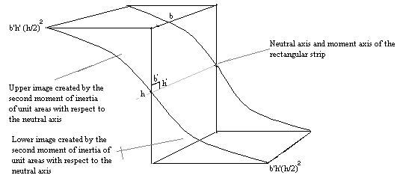
b’ x (no. of division of b) = b
h’ x (no. of division of h/2) = h/2

$$\sum{b'h'{\left(\frac{h}{2}\right)}^{2}=b\frac{h}{2}\frac{h^{2}}{4}\frac{1}{3}=\frac{{\text{bh}}^{3}}{\text{24}}}=I_{L}=I_{U}$$

1/3 of a rectangular prism created by
the dimensions b x h/2

$\sum{b'h'{\left(\frac{h}{2}\right)}^{2}}$is the area moment of inertia of either the upper or the lower image of the second moment of inertia. Therefore, the I, or the moment of inertia of the rectangular strip is:

$$I=2I_{L}=2\left[\sum{b'h'{\left(\frac{h}{2}\right)}^{2}}\right]=\frac{{\text{bh}}^{3}}{\text{12}}$$

- Area Moment of Inertia of a triangular strip with moment axis at the top of the figure. The value of the Moment of Inertia will be taken through the image generated by the first moment of unit areas:

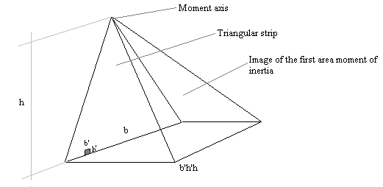

Treat the image as a pyramid with a base b’h’h x b, and height of h, and centroid of 3h/4 from the moment axis:

b’ x (no. of division of b) = b
h’ x (no. of division of h) = h

$$\sum{b'h'h=\text{bhh}\frac{1}{3}=\frac{{\text{bh}}^{2}}{3}}$$

The pyramid has an area of 1/3 that
of a rectangular prism of dimensions: b’h’h x b x h

$$I=\sum{b'h'h\left(\frac{3h}{4}\right)=\frac{{\text{bh}}^{3}}{4}}$$

- Area Moment of Inertia of a triangular strip with moment axis at the top of the figure. The value of the Moment of Inertia will be taken through the image generated by the second moment of unit areas (next page):

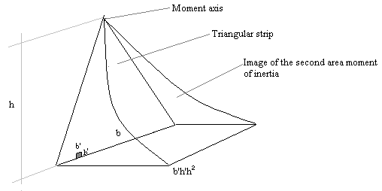

Treat the image as a figure with a base of b’h’h² x b and height of h. Its volume would be one fourth that of a rectangular prism with same base and height ( which can be proven by Integral Calculus). Again,

b’ x (no. of division of b) = b
h’ x (no. of division of h) = h
Therefore:
$$I=\sum{b'h'h^{2}={\text{bhh}}^{2}\left(\frac{1}{4}\right)=\frac{{\text{bh}}^{3}}{4}}$$

5. Area Moment of Inertia of an inverted triangular strip with moment axis at the top of the figure. The value of the Moment of Inertia will be taken through the image generated by the first moment of unit areas:

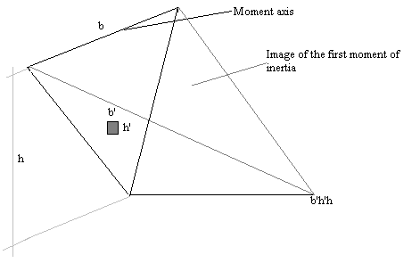
Treat the image as a pyramid with base ½ b x h and height of b’h’h.

b’ x (no. of division of b) = b
h’ x (no. of division of h) = h

$$\sum{b'h'h=\frac{\text{bh}}{2}h\frac{1}{3}=\frac{{\text{bh}}^{2}}{6}}$$

1/3 of a rectangular prism

$$I=\sum{b'h'h\left(\frac{h}{2}\right)=\frac{{\text{bh}}^{2}}{6}}\left(\frac{h}{2}\right)=\frac{{\text{bh}}^{3}}{\text{12}}$$

h/2 is the distance of the centroid of the figure to
the moment axis which can be acquired
by Integral Calculus

6. Area Moment of Inertia of an inverted triangular strip with moment axis at the top of the figure. The value of the Moment of Inertia will be taken through the image generated by the second moment of unit areas:

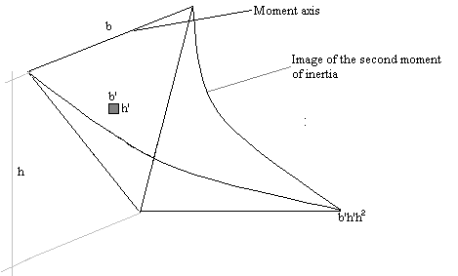

We can employ an alternative approach to evaluate the value of the Moment of Inertia: Integral Calculus (next page).
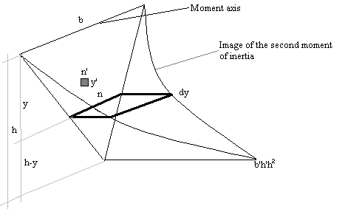

n’ x (no. of division of n) = n
y’ x ( no. of division of y) = dy
$\frac{n}{h−y}=\frac{b}{h}$ therefore $n=\frac{b\left(h−y\right)}{h}$

$$\begin{aligned}d\sum{b'h'h^{2}={\text{ny}}^{2}\text{dy}} \\ \sum{b'h'h^{2}=\frac{b}{h}\int_{0}^{h}{\left({\text{hy}}^{2}−y^{3}\right)\text{dy}}}=\frac{{\text{bh}}^{3}}{\text{12}}\end{aligned}$$
I = bh³/12
7. Mass moment of inertia of a solid plate with moment axis at the top of the figure. The value will be taken through the image generated by first moment of unit mass:
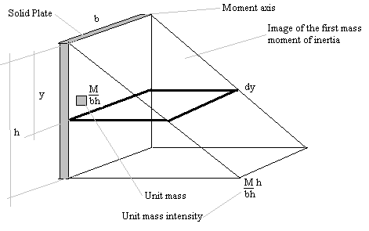

Let M = Mass of the plate
Centroid of the image is at 2/3 from the moment axis.

$\begin{aligned}d\sum{\frac{M}{\text{bh}}h=\frac{M}{\text{bh}}\text{bydy}} \\ d\sum{\frac{M}{\text{bh}}h=\frac{M}{h}\text{ydy}} \\ \sum{\frac{M}{\text{bh}}}h=\frac{M}{h}\int_{o}^{h}{\text{ydy}} \\ \sum{\frac{M}{\text{bh}}h=\frac{\text{Mh}}{2}} \\ I=\sum{\frac{M}{\text{bh}}h\left(\frac{2h}{3}\right)} \\ I=\frac{\text{Mh}}{2}\left(\frac{2h}{3}\right) \\ I=\frac{{\text{Mh}}^{2}}{3}\end{aligned}$

Centroid from the moment axis

